File permissions in Linux

Project description
MANAGE AUTHORIZATION

Check file and directory details
- USED the command PWD to see which directory we’re navigating in. In this case the /home/researcher2 file path. We change the directory to the projects folder. Once in the folder we use the ls -l command in order to list the contents in the folder.
- The contents shown below are documents for the research_team group.
- 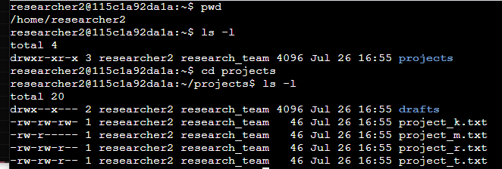

Describe the permissions string
- drwxrwxrwx is the default permissions that is assigned for Read, Write, and Execute permissions for User, Group, and Other in a Directory folder.
- D - directory
- Rwx - R - Read, W - Write, X - Execute
- 1st rwx - user,rwx - group, rwx - other
- Requires command chmod in order to modify permissions
- For example project_m.txt, the permissions read as -rw-r----
- rw- User has Read, Write - Permissions
- -r- Group has Read-Only Permissions
- --- Other has no Read, Write, or Execute Permissions

Change file permissions
- We check the files in the projects directory to see if any of the projects have write permissions for the owner type.
- For project_k.txt this is the only file that grants permissions to other users for write permissions
- As written for project_k.txt:
  - -rw-rw-rw
- We use the command chmod o-w project_k.txt chmod means change mode or change modification. The o-w alongside chmod means other user take away (-w) write permissions from project_k.txt
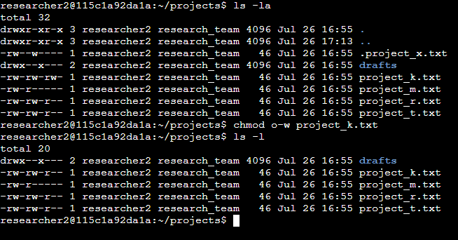

Change file permissions on a hidden file
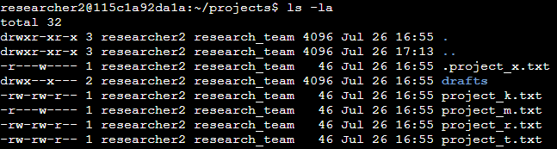

We use the command ls -la in order to list hidden files. We find a hidden file called .project_x.txt. The current file shows the permissions are written as -r---w---- . This file permission for the group is incorrect write permissions. For the hidden file .project_x.txt

We change the user permission on .project_x.txt so that the user and the group can have read-only permissions, but no write permissions to the file. We use the command chmod u-w,g-w,g+r .project_x.txt in order to make the necessary changes on user permissions.

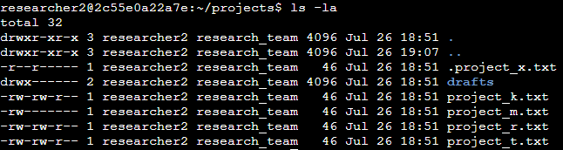

Change directory permissions
drwx --x --- drafts
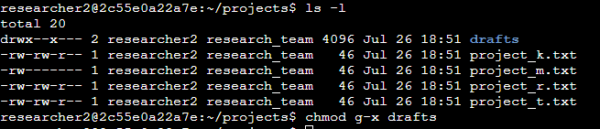

drwx --- --- drafts
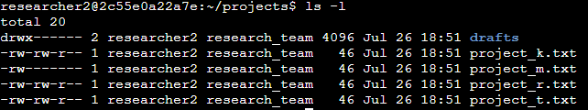

Summary
[Add content here.]

